Trackwrestling Instructions
- Go to www.trackwrestling.com

- Click “Events” then “Search Events”
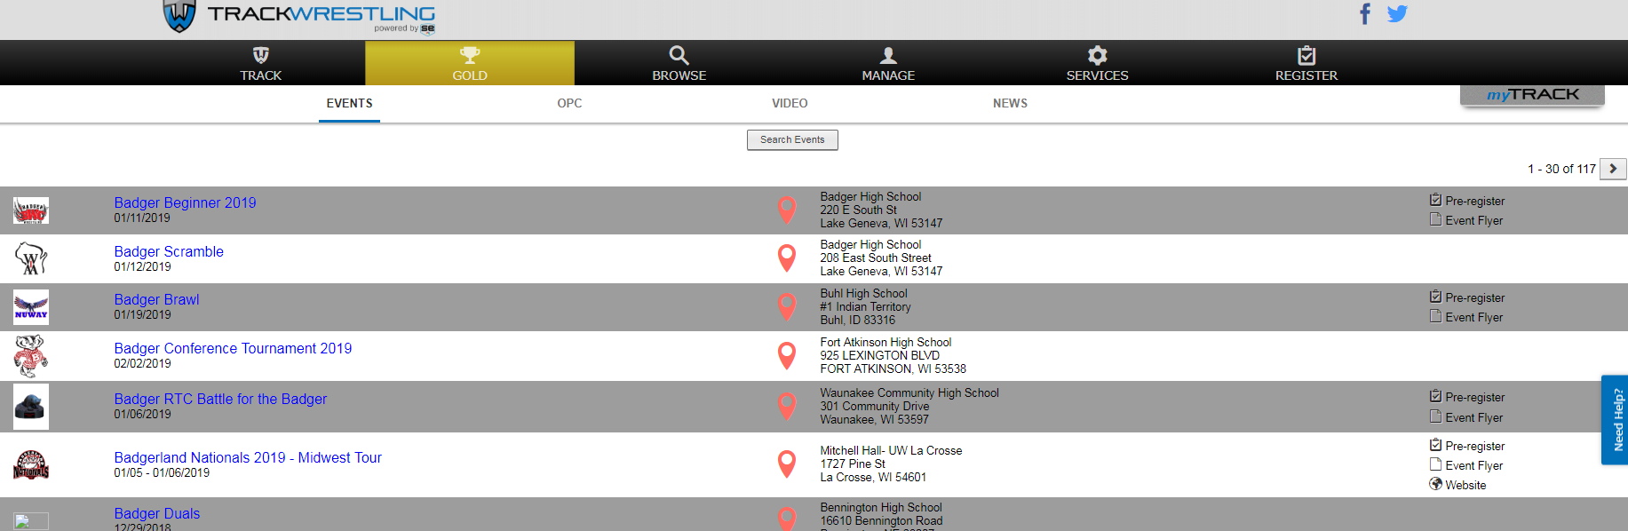
- Click “Advanced”. This will allow you to populate only youth tournaments taking place in Wisconsin. For “State” select Wisconsin and for “Age Level” select Youth.
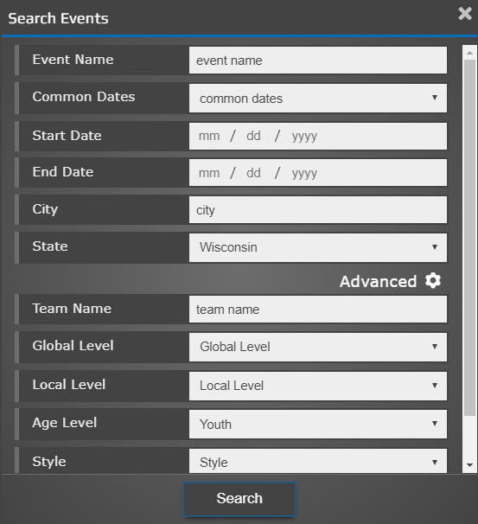
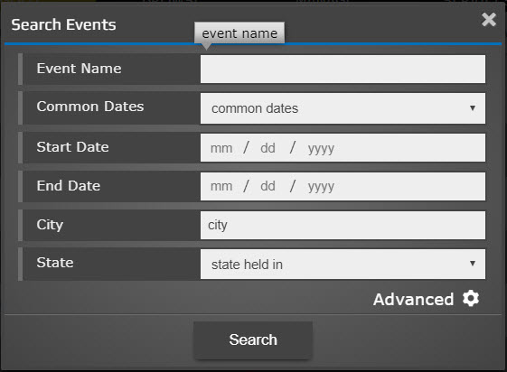

- Hit “Search” and you will see all the tournaments taking place in Wisconsin.

- When tournaments populate click on the name of the tournament you want to attend.

- Select “Viewer” and hit Enter Event
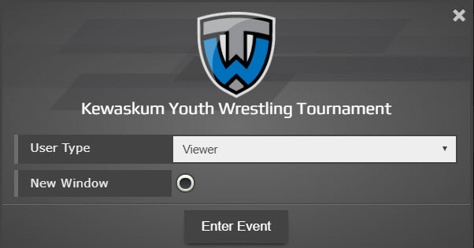
- Click “Registration”
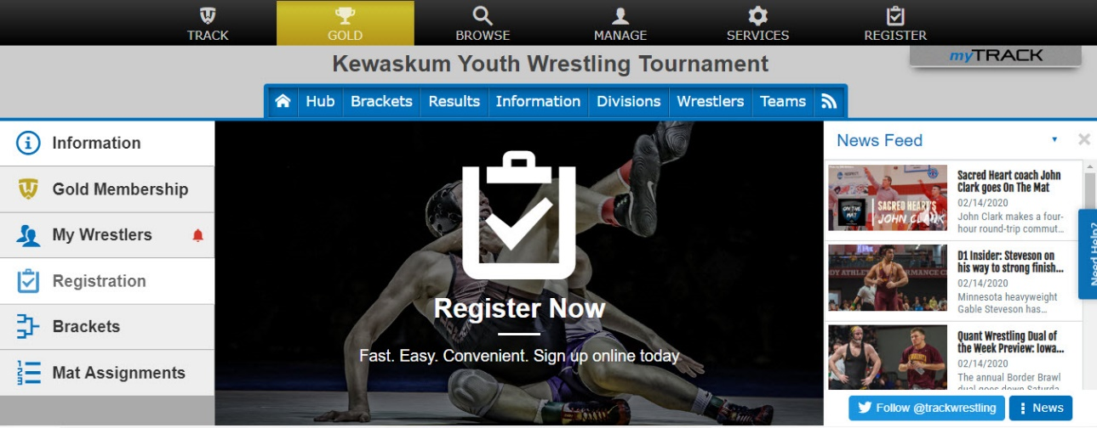

- Enter your “Trackwrestling # or Username” and “Password” to sign in.
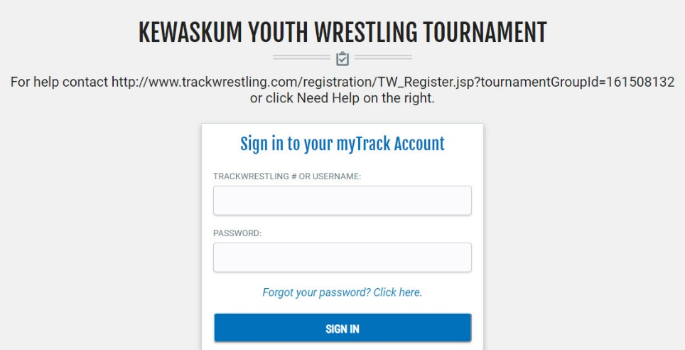

- Select the wrestler you want to register and then click “Register Selected”.
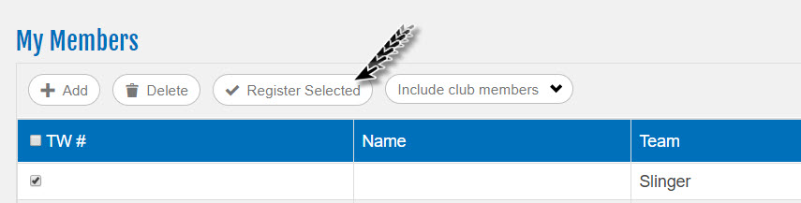

- Make sure all the information listed is correct for the wrestler you are registering, then click “Next”
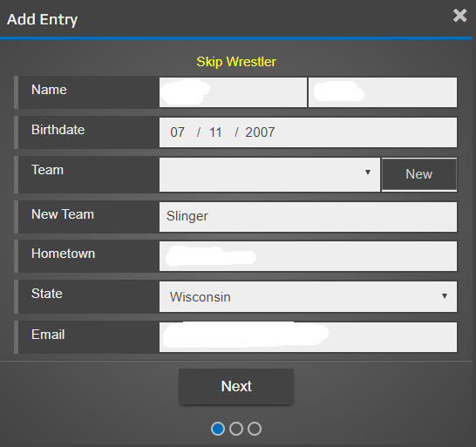

- Your USAW ID should automatically populate, so just make sure grade and weight are correct.
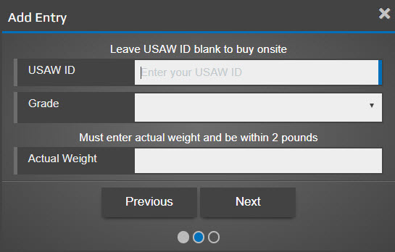

- Make sure you put a check in the box and then select the correct “Division” and “Separation Criteria” for your wrestler. Click “Add Wrestler”.

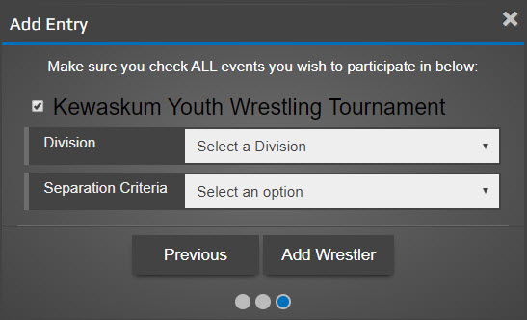

- If you have another wrestler to register, this is where you would click “Add Another Wrestler” and follow the prompts on the screen. OR If you only have one wrestler, click “Continue”.
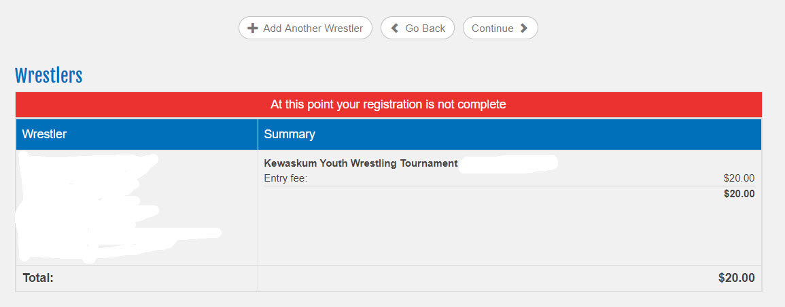

- Click on “Checkout” to make your payment
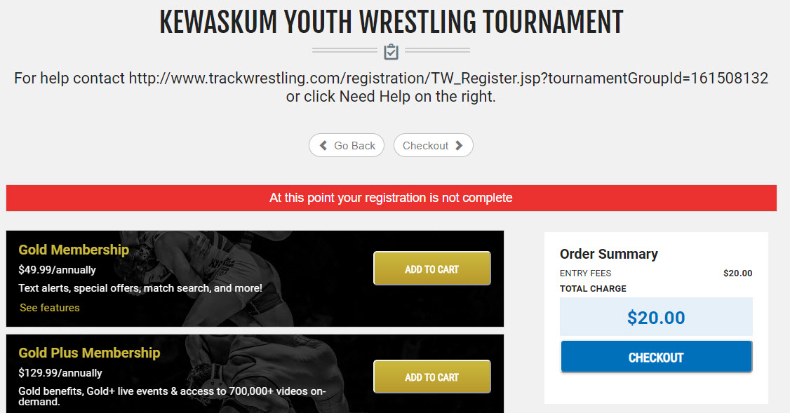
- Once registration and payment is complete you will receive a confirmation email.

